1.Create a view with name ‘std_view’ using STUDENT table which holds the value of register number, name and DOB of student.

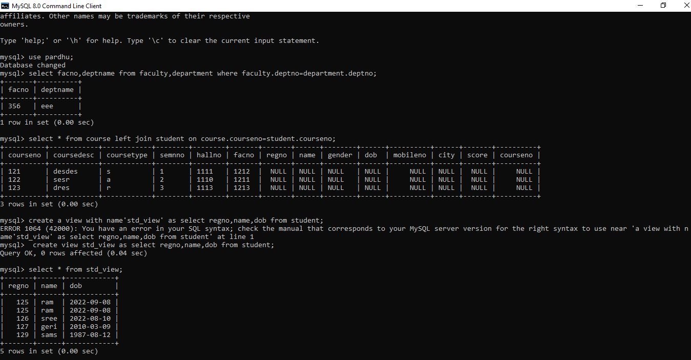

2.create an index on courseno of student and analyse the performance.

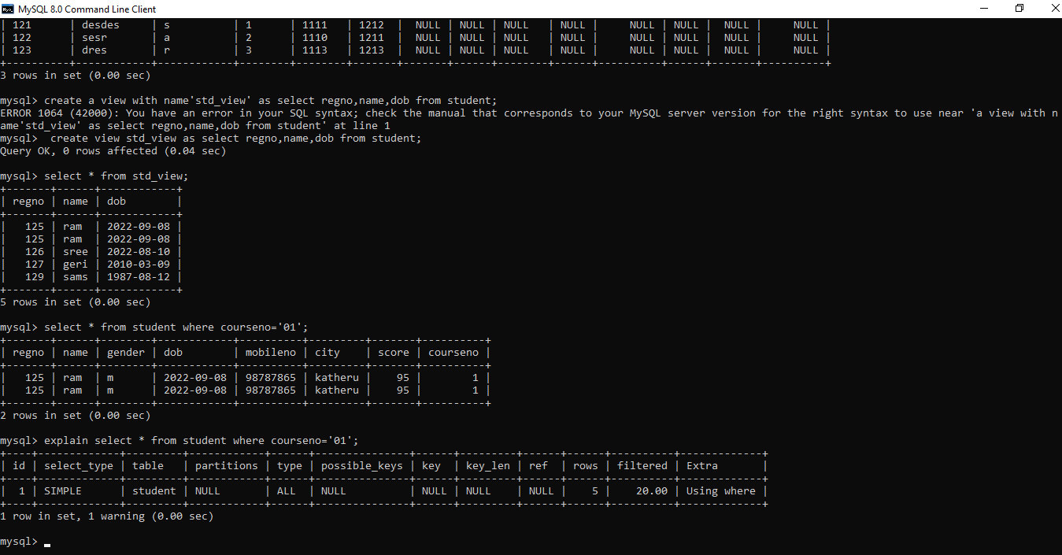

3.create an example sequence..?

